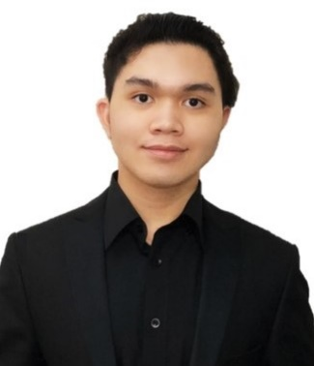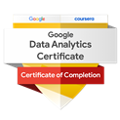

I am a ACCA Professional and a Graduate of Bachelor's Degree (BSc) of Applied Accounting from Oxford Brookes University. I am also passionate with digital automation towards promoting a data driven and customer centric working environment.

**IAN CRIS TOCLE**

I hereby certify that the facts contained in this resume are true and complete to the best of my knowledge

**Phone:**

971 502832003

**E-Mail:**

[ic.tocle@gmail.com](mailto:christoper.morgan@gmail.com)

**Linkedin:**

www.linkedin.com/in/ian-cris-tocle-

# Personal Info

Nationality: Filipino

Birth Date: 31 October 2003

Religion: RC - Christian

Sports: Basketball & Chess

# Hobbies

Performer: Musician (Violinist / Pianist / Guitarist)

Singer and Vlogger

# Visa

Residence Visa – Father’s Sponsorship Visa Valid till 2025

# Languages

English

Tagalog

# Education and Certificates

BSc Accountancy – Oxford Brookes University (OBU)

ACCA – Advanced Diploma in Accounting and Business

Financial Analyst Certification

IBM Professional Certificate

Google Analytics Professional Certificate

Microsoft Power BI Certificate – On going

# Projects

* Google Data Analysis Capstone Project
* IBM Data Analysis Capstone Project
* Machine Learning Auto-Attendance + AI Facial Recognition (Python)
* Budgeting and Forecasting (Excel Template)
* Aged Receivable and Payable Analysis (Excel Template)
* Inventory Stock Analysis (Excel Template)
* Financial Statement Analysis (Excel Template)
* Power BI Dashboard and Reports Analysis
* Cheque Payment Voucher Template (Excel / VBA)
* Tableau – Data Visualization
* Full-Depth Financial Report and Research Analysis Thesis (OBU)

# Knowledge and Skills

* Financial and Data Analyst
* Power BI and Tableau Data Visualizations
* Python Framework and Libraries (Jupyter-IDE)
* HTML-CSS-JavaScript/Power Page/WordPress (VSCode)
* Public Speaking - (Gavels and PBS)
* MS – Office Excel / Word / PowerPoint
* Social Media Creator / Editor
* Photo / Video Editing
* PC Networking / Gaming

# References

References available on request

IAN CRIS RAYA TOCLE

Bsc-Accountancy Oxford University